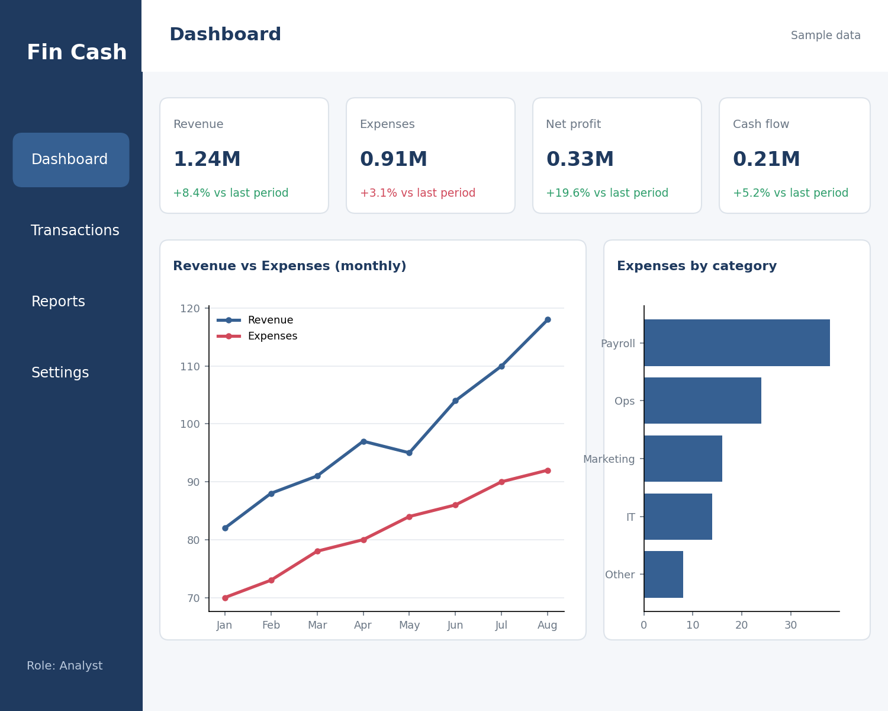
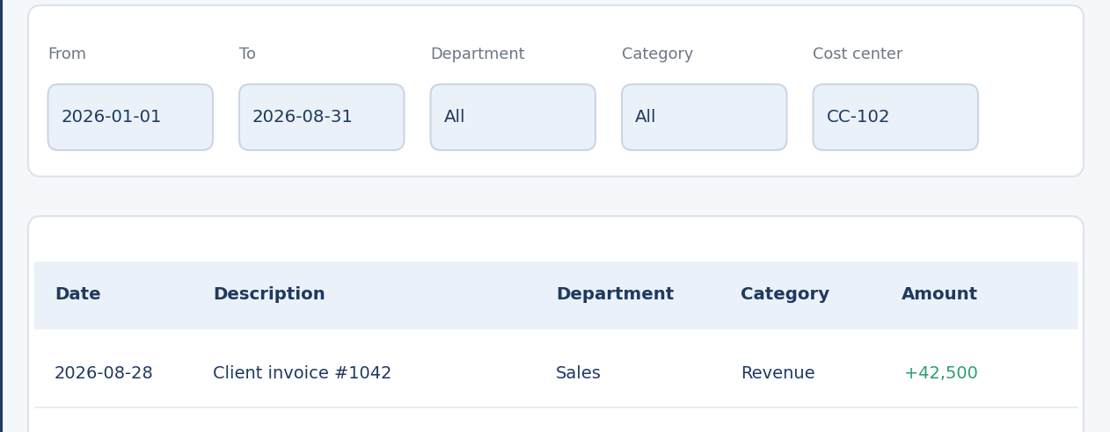
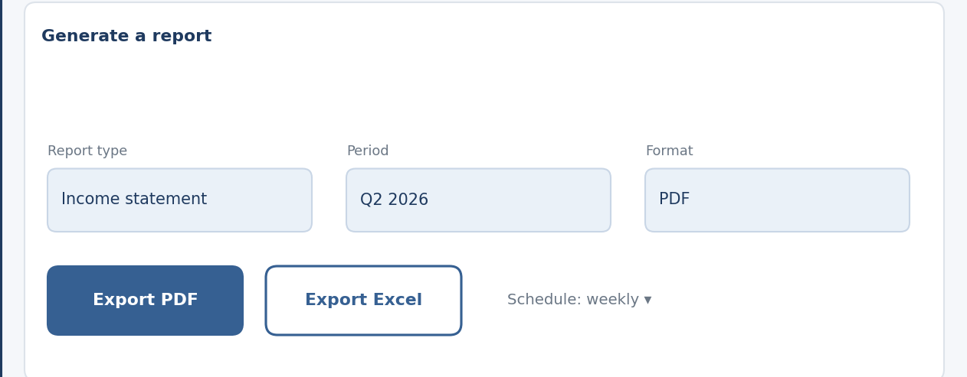



Fin Cash – Financial Analytics Platform
Backend
• ASP.NET Core Web API
• Entity Framework Core · SQL Server
• JWT authentication · Swagger / OpenAPI
Frontend
• React · Axios · Recharts · TailwindCSS
Tooling
• Git · GitHub Actions · Docker (optional)
Prototype
Jones, M., Bradley, J., & Sakimura, N. (2015). JSON Web Token (JWT) (RFC 7519). IETF. https://www.rfc-editor.org/rfc/rfc7519
Meta Platforms, Inc. (n.d.). React documentation. https://react.dev
Microsoft. (n.d.). ASP.NET Core documentation. Microsoft Learn. https://learn.microsoft.com/aspnet/core
Microsoft. (n.d.). Entity Framework Core documentation. Microsoft Learn. https://learn.microsoft.com/ef/core
Materials
References
1. Defined the problem and the target users: finance teams, analysts and executives.
2. Designed a layered architecture: Controllers → Services → Repositories → EF Core, plus a React SPA.
3. Modeled the data in SQL Server using EF Core migrations.
4. Built the REST API (login, dashboard summary, transactions, report export) and documented it with Swagger.
5.Built the React interface with dashboard, reports, Quick Search & Filter and monthly summary cards.
6. Secured access with JWT and Admin / Analyst / Viewer roles.
7.Tested the system and planned budget alerts and AI-powered financial analysis as additional features.
Methods

Group Number: 13 Students Names : Mohamed Waleed , Marwan Hazem , Youssef Mohamed , Sama Adel , Yumna Reda.

Abstract
Results and data analysis
Conclusions

Business Model Canvas
Key Partners
• Cloud hosting providers
• Accounting & ERP software vendors
• Banks / payment data providers
• Finance consultants
Key Activities
• Develop & maintain the platform
• Integrate data sources
• Security updates
• User onboarding & support
Value Proposition
• Single source of truth
• Real-time KPIs
• Drill-down analytics
• PDF / Excel reports
• Secure role-based access
• Open REST API
Customer Relationship
• Self-service dashboard
• Onboarding & documentation
• Priority support for companies
Customer Segments
• Finance teams
• Financial analysts
• Executives (CFO)
• Small & mid-size companies
Cost Structure
• Development & maintenance
• Cloud hosting & SQL Server licensing
• Security & compliance
• Marketing & customer support
Revenue Streams
• Subscription per user / plan (Admin, Analyst, Viewer seats)
• Setup & integration fees
• Premium support
• API access plans
Channels
• Web application
• Direct sales & demos
• Swagger-documented API for integrators
• Online / LinkedIn marketing
Key Resources
• Development team (.NET / React)
• Cloud infrastructure & SQL Server
• Source code & documentation
•Add Smart Budget Monitoring with spending alerts and overspending predictions
•Add AI-based anomaly detection, financial summaries and expense forecasting
•Add Quick Search & Filter and a monthly financial summary selector
• Support multiple currencies and company entities
Introduction
Recommendation
What the platform delivers:
• Live dashboard with revenue, expenses, net profit and cash-flow KPIs
•Time-series charts, period comparisons and monthly revenue / expense / net-profit summary
•Quick Search & Filter: search by transaction name; filter Revenue or Expense
•Smart Budget Monitoring: track department budgets and warn about likely overspending
•AI features: flag unusual expenses, summarize financial changes and forecast future expenses
Survey results (n = [__] responses):
Graph 1: [title of the graph]. [One-sentence finding, e.g. 70% of users ...]
Graph 2: [title of the graph]. [One-sentence finding.]
What we achieved: A working analytics and reporting platform: one dashboard, drill-down analytics, filtered views and exportable reports behind role-based access.
Did it solve the problem? Yes. Fin Cash removes manual consolidation and gives teams a single, current view of performance.
Limitations: Needs more testing with real company data and a larger group of users.
Purpose: Give finance teams one reliable, real-time view of business performance.
Problem: Financial data is scattered across spreadsheets and disconnected systems, so reporting is slow, error-prone and hard to trust.
Solution: Fin Cash, a web platform (ASP.NET Core API + React) that consolidates data into a single source of truth: a live KPI dashboard, drill-down analytics, advanced filtering and PDF / Excel reports, protected by role-based access.
Conclusion: Fin Cash replaces manual consolidation with decision-ready insights for finance teams, analysts and executives.
Purpose: Turn scattered financial data into one trusted source of truth and give decision-makers fast, accurate insights.
Problem: Teams juggle spreadsheets and disconnected systems. Numbers are copied by hand, versions conflict and reports arrive late, which delays decisions and invites errors.
Prior solutions: Manual spreadsheets and separate accounting or reporting tools. They work for small data sets but give no live, consolidated view and are hard to control by role.
Our solution (strengths & weaknesses):
• Strengths: single source of truth, real-time KPIs, drill-down analytics and filtering, PDF / Excel export, JWT role-based security and an open REST API documented in Swagger.
• Weaknesses: results depend on the quality of the input data, and direct connectors to external accounting systems are still future work.
Reference: Built on documented, industry-standard technologies (ASP.NET Core, EF Core, React, JWT). See References.

